Anthozoans

1.Sea Anemones: The external morphology of anemones is limited to a column; an oral disk, in the center of which the mouth is located, and on which the tentacles are located; and either a pedal disk, that affixes the anemone to the substrate, or a bulb-like lower end (physa), used by burrowing anemones to anchor in soft substrate. Watch a sea anemone feed and then follow instructions to view nematocysts.

Aiptasia the model sea anemone: The external morphology of anemones is limited to a column; an oral disk, in the center of which the mouth is located, and on which the tentacles are located; and either a pedal disk, that affixes the anemone to the substrate, or a bulb-like physa, used by burrowing anemones to anchor in soft substrate.

.

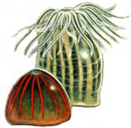

*Aiptasia pallida*, or related species, has long tentacles and demonstrates partial retraction. Because they reproduce by budding, a few well-fed individuals will soon multiply to hundreds and cover the rocks like soft brown fuzz.

Obtain and examine a specimen of *Aiptasia pallida*. This anemone, contains symbiotic dinoflagellates or unicellular algae.

*Apitasia* is fairly transparent and so you should be able to see the food moving down into the gut. It feeds on most motile organisms. It will often take animals twice or three times its size.

Feed your specimen a small piece of fish food.

How close is the prey before the anemone response to it. Do the tentacles move toward the prey or does the prey have to contact the tentacles before the anemone responds. How does the sea anemone move the prey animal into the digestive cavity? Can you see any other details of internal anatomy in your specimen? **Record your observations in your journal.**

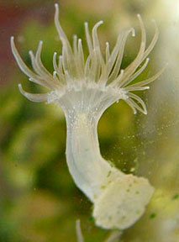

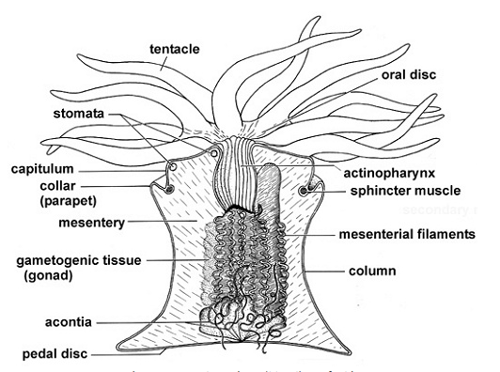

**Pairs should exchange information and then all should be able to look at cnidoblast cells at the same time.**

Your teaching assistant will choose a specimen to use to examine the stinging cells or cnidoblasts. Obtain a tentacle or two and place under 100 or 200 x. Look closely at the surface to see the conspicuous spherical **nematocysts**.  These are the explosive capsules of cnidocytes.  The cnidocytes themselves will probably not be discernable but their capsules are abundant and conspicuous. You may also see some yellow to yellow orange circular cells that are spilling out of the tentacles. These are symbionts, or dinoflagellates found in this species.

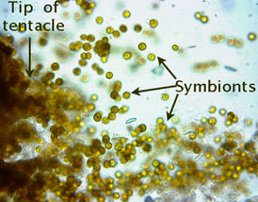

Some pairs may want to place the acontia or white protective threads that appear when the anemone feels threatened, (as when its tentacles are cut off). Anemones can have cnidocytes lining the inside of the gastrovascular cavity and their acontia.

Look at one of the tentacles with 400X.  Note the different sizes of **nematocysts**.  Most of the nematocysts will be intact and unexploded but some will have discharged.  Find some of the large ones, focus carefully, and look for a coiled **thread** inside the capsule.  If the thread is present, the nematocyst is undischarged.  Look around for some **discharged nematocysts**.  These will look quite different.  They are obviously empty, having everted their **thread**, which can be clearly seen extending away from one end of the empty capsule. With careful focusing and light adjustment you can also see the formidable **barbs** at the base of the thread adjacent to the empty capsule.

Place a drop of 1% acetic acid beside the coverslip and draw it under *while watching* through the microscope.  The acid may stimulate the discharge of many of the nematocysts and, if you are fortunate, you may actually see one of them discharge as you watch.  A drop of toluene blue applied the same way will stain the nematocysts, making them easier to see.

**Obtain (a.) a photograph of a tentacle, discharged nematocysts and symbionts. Identify symbiotic algae and nematocysts on the photograph**

2. **True corals**

Included in the Anthozoa are the true corals.

A colony of Astrangia asteriaformes resembles a miniature reef coral, with polyps ranging in color from pink to white. You may have to use high light on these species to see their refracted colors. We will only have two small colonies of these to observe, so just examine them and compare their structure to that of *Aiptasia in your journal*. They show true colony integration. Lightly touch one if the polyps are extended and watch the entire colony respond.

3. Gorgonians and other soft corals,

Gorgonians and sea pansies are also known as octocorals, so named

because the individual polyps have eight tentacles. If you look closely at the branches of a soft coral, you may see the tiny tentacles of the individual polyps. Each of these tentacles may looks like it is feathered because it can bears numerous outfoldings. The main purpose of this exercise is for you to observe these animals and be able to compare them to the hydroid colonies you observed previously (*Hydractinia* and any hydroids available today), Many gorgonians, sea pansies or pens look superficially like hydroid colonies, but on close examination, you can see their more “sea anemone” or anthozoan morphology. You will need to record your observations in your journal. Obtain photographs that will allow you to tell the difference between anthozoan and hydrozoan polyps.

Octocorals that may be available.

***Pinnigorgia flava***

This species was originally collected in the Philippines around 1990 by Klaus and Rosalia Grube’s gorgonian or the Grube. From their aquarium in Berlin it has spread all over Europe and America. This Gorgonian is a graceful, thin-branched octocoral that can be described as tan to pink in color with similarly colored polyps. Zooanthellae may be present

Leptogorgia virgulata Species sent not identified, but probably related to this one.

This is also a tree-shaped gorgonian with colorful ( colors can range from tan to purple) branches rising in all directions from a short, main trunk

**Lophogorgia hebes**, This is a brick red, densely branching sea fan.

**Cavernularia sp.** a sea pen

The base of this colony burrows into the sand, erecting its upper half which contains hundreds of specialized polyps to feed. Though primarily sessile, Sea Pens are able to uproot and move to where conditions are favorable

Renilla mulleri, a sea pansy, Available in lab today

This colony looks like a bit of a sponge with fuzz on it. Polyps are vividly luminescent when handled in the dark. It as the sea pen has a peduncle or base that anchors it to the substrate.

Look at a portion of a Gorgonian colony. Sea pansy should be the easiest to examine under the dissecting scope. Be patient as it may take a while for the individuals to relax and expand. Focus on the tentacles and see if you can observe their “pinnate” nature. Count number of tentacles. Obtain a photograph of a soft coral polyp and indicate “octocoral” features**.**